Restack
J. Potgieter

1. Project Overview
Restack is a management solution designed to handle customer relationships and financial documentation. By leveraging the ABP Framework, it follows a strictly layered, Domain-Driven Design (DDD) architecture, ensuring scalability and maintainability.

2. Core Components (Angular UI)
The application is partitioned into three primary functional areas:
- Customer Component: Manages profile data, contact information, and history.
- Invoice Component: Handles the generation and configuration of billing documents, including automatic ID generation.
- Invoice Lines Component: A sub-component used within the Invoice view to manage itemized billing entries (quantity, unit price, and descriptions).

3. Backend Architecture & Project Structure
The backend follows the ABP layered monolith template. Here is the specific mapping of your business logic:

Models & Entities
- Project: Restack.Domain
- Path: Restack.Domain/Invoices/Invoice.cs, Restack.Domain/Customers/Customer.cs
- Purpose: These are the "Source of Truth." They contain the state and business rules for the database.

Data Transfer Objects (DTOs)
- Project: Restack.Application.Contracts
- Path: Restack.Application.Contracts/Invoices/Dtos/ and Restack.Application.Contracts/Customers/Dtos/
- Purpose: These are the models shared with the Angular frontend. They are serializable classes used to transfer data between the API and the UI.

4. Data Access & Persistence
Restack uses Entity Framework Core (EF Core) as the ORM (Object-Relational Mapper) with SQL Server as the database engine.

Entity Framework Core Configuration
- DbContext: Located in Restack.EntityFrameworkCore. This class (RestackDbContext) manages the mapping between C# entities and SQL tables.
- Migrations: Database schema changes are tracked in the Migrations folder within the Restack.EntityFrameworkCore project.
- Migration Commands:
  - dotnet ef migrations add Added_Invoice_Entity (Creates the script).
  - dotnet ef database update (Applies changes to SQL Server).

5. Database Schema (SQL Server)
The following diagram illustrates the primary entities and their relationships within the SQL Server database.
- Customer 1:N Invoice: One customer can have many invoices.
- Invoice 1:N InvoiceLine: One invoice contains multiple line items.

Activity Diagram

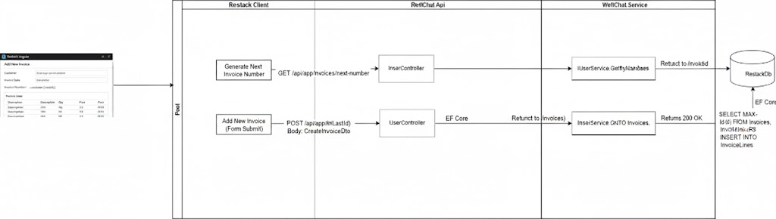
Fig 1. Activity diagram

